**Exp. No : 1**

# Installation of Hadoop

1. Download Hadoop Binary file

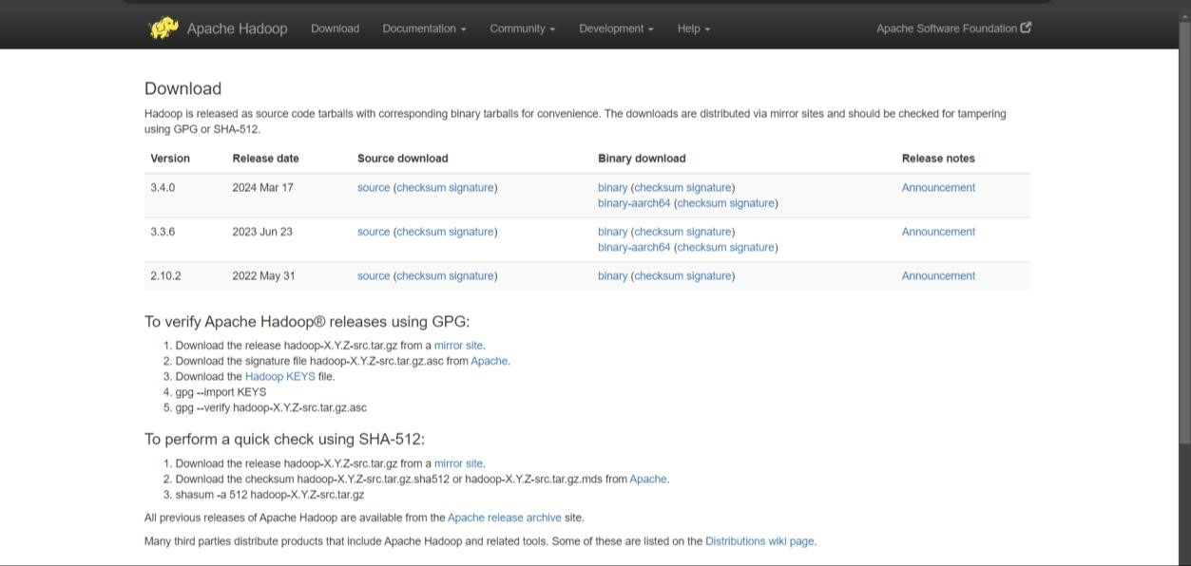

1. Modifying .bashrc file

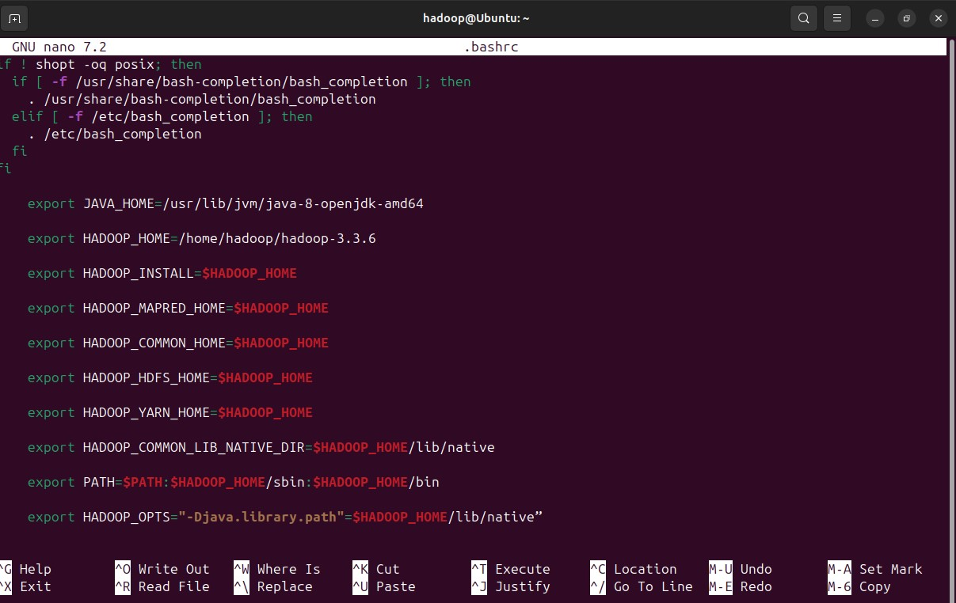

1. Updating JAVA_HOME in $HADOOP_HOME/etc/hadoop/hadoop-env.sh

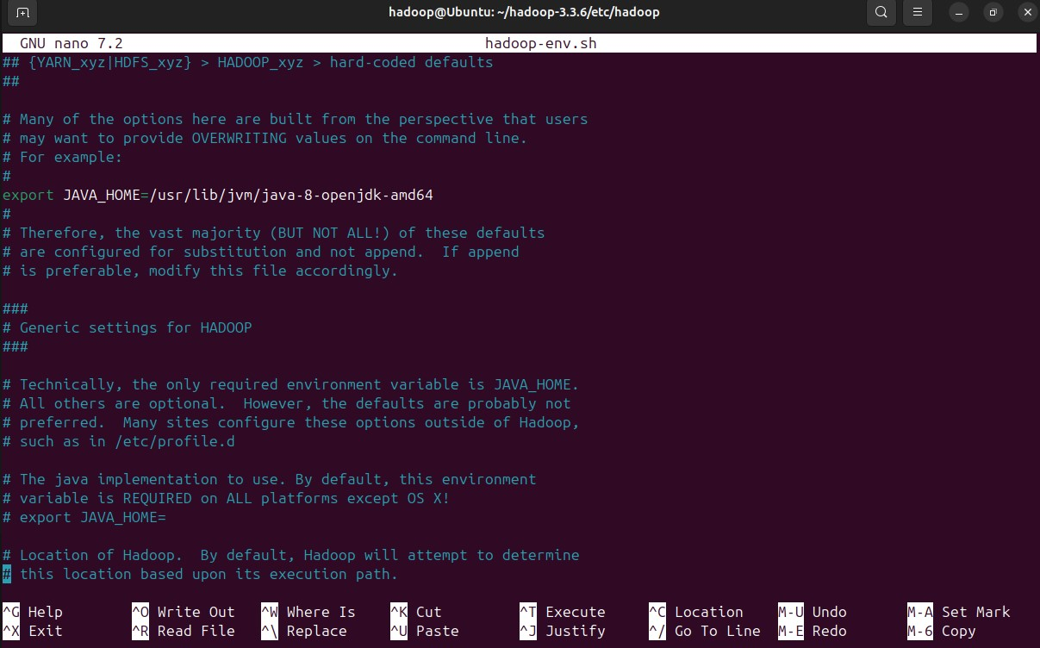

1. Modifying $HADOOP_HOME/etc/hadoop/core-site.xml

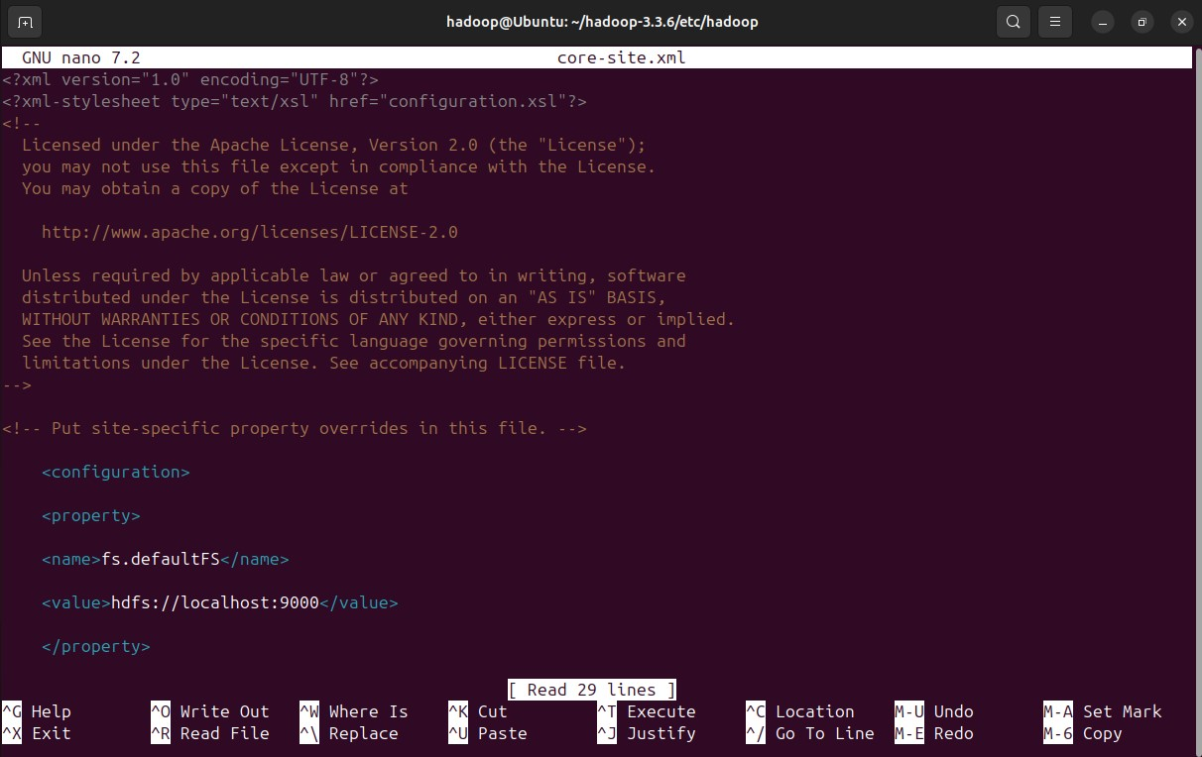

1. Modifying $HADOOP_HOME/etc/hadoop/hdfs-site.xml

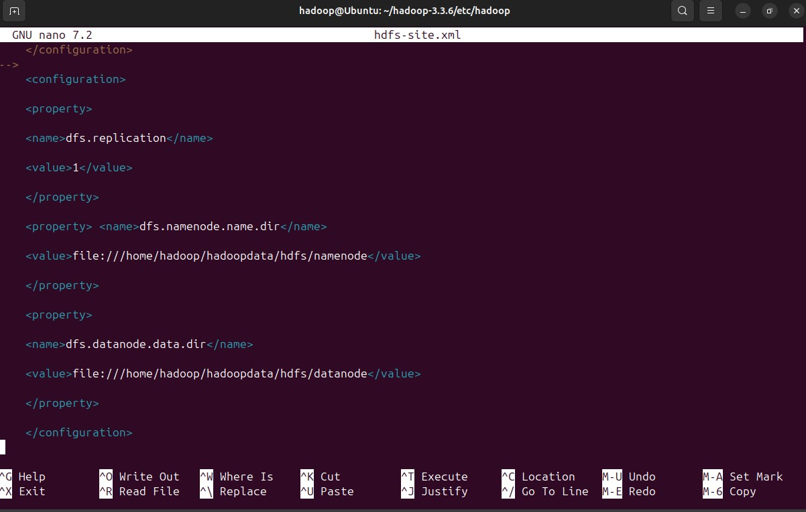

1. Modifying $HADOOP_HOME/etc/hadoop/mapred-site.xml

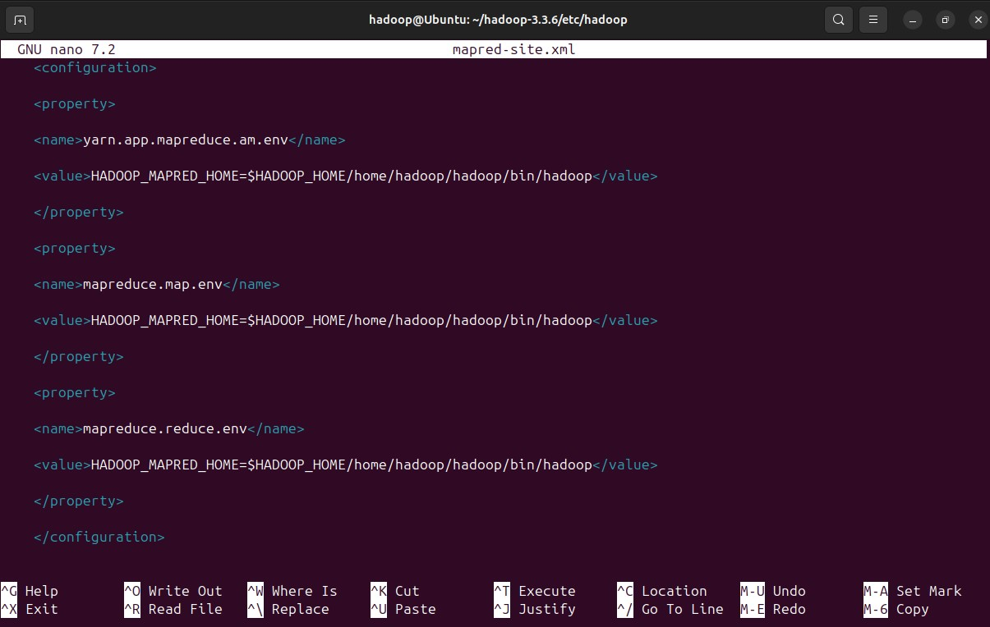

1. Modifying $HADOOP_HOME/etc/hadoop/yarn-site.xml

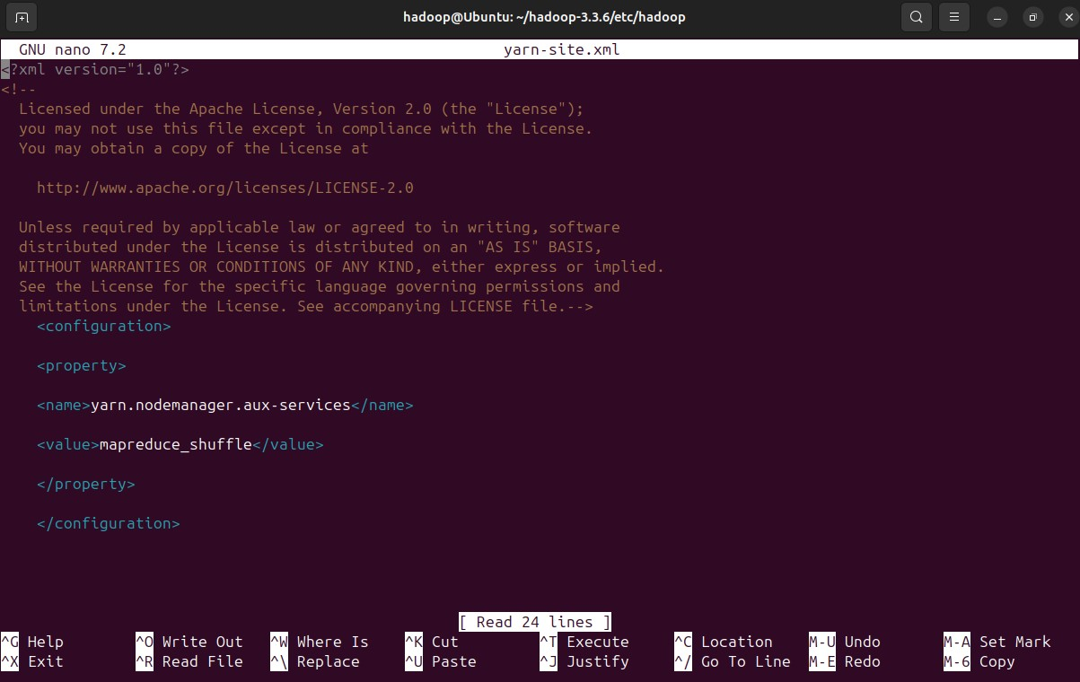

1. Execute hdfs namenode -format

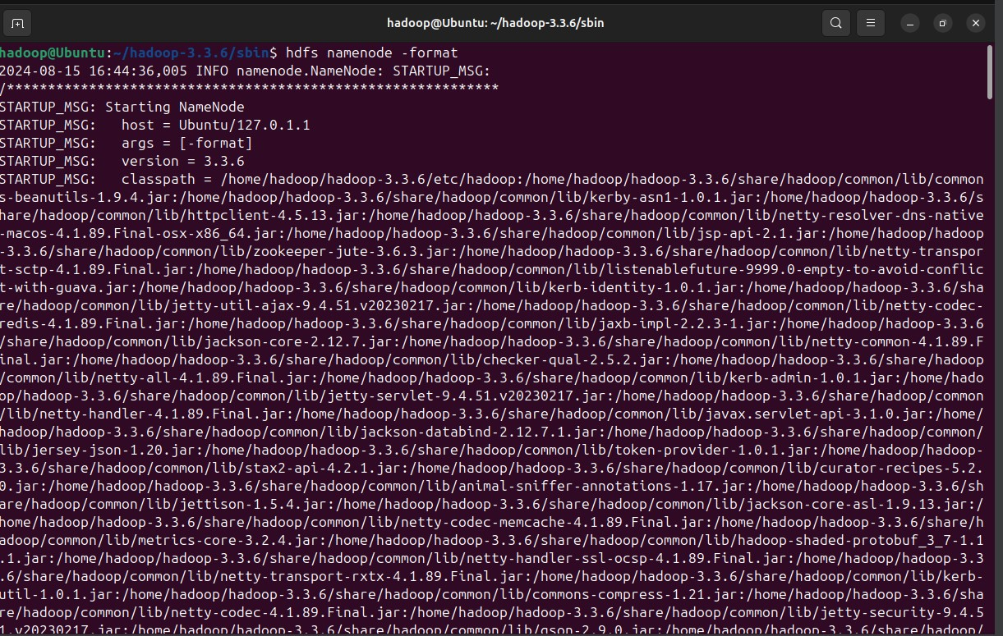

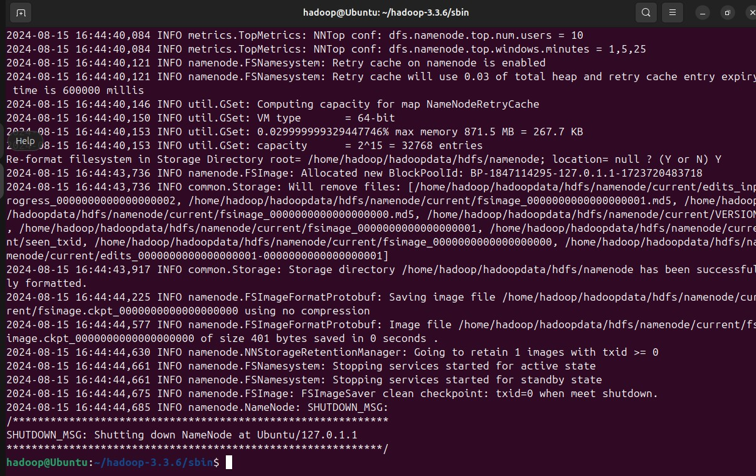

1. Execute start-dfs.sh

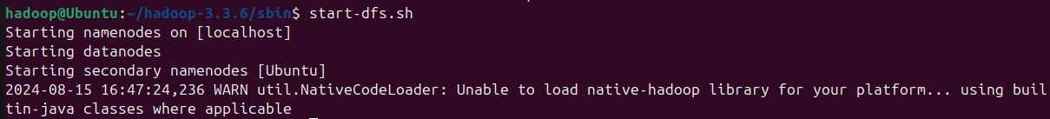

1. Execute start-yarn.sh



1. Execute jps command



## 12. Open [http://localhost:9870](http://localhost:9870/)

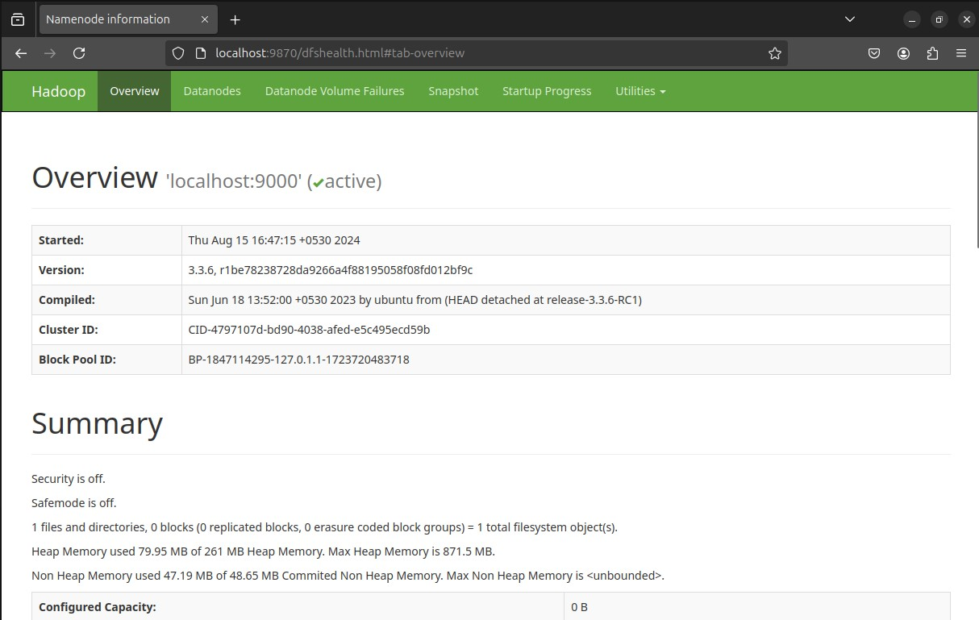

## 13. Open [http://localhost:8088](http://localhost:8088/)

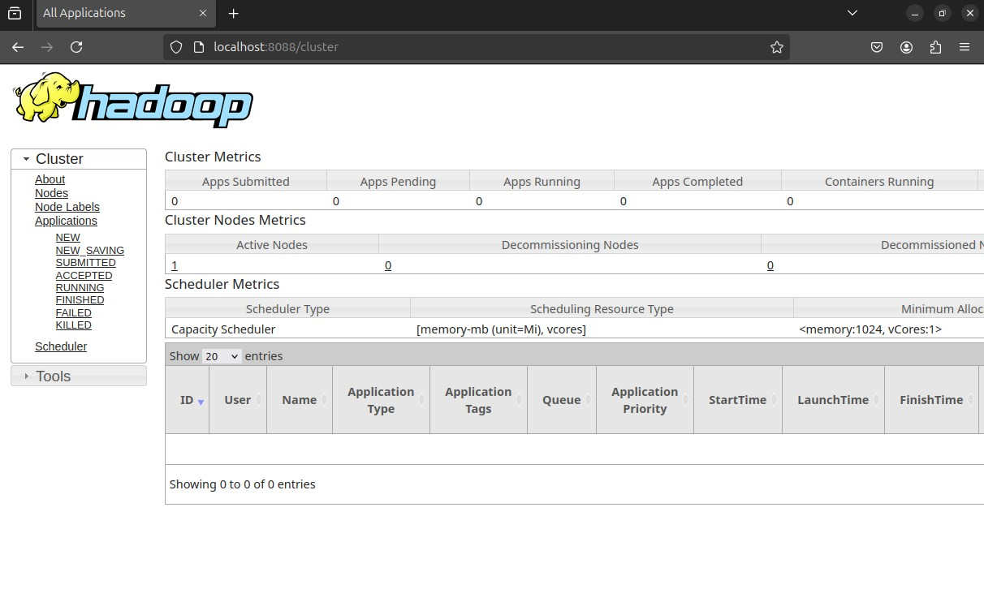

## 14. Open [http://localhost:8042](http://localhost:8042/)

